- INTRODUCTION

Extreme sports (also called action sports and adventurous sports) is a popular term for certain activities perceived as having a high level of inherent danger. These activities often involve speed, height, a high level of physical exertion, and highly specialized gear.
An adventure is an exciting or unusual experience. It may also be a bold, usually risky undertaking, with an uncertain outcome.Adventures may be activities with some potential for physical danger such as exploring, skydiving, mountain climbing, river rafting or participating in extreme sports. The term also broadly refers to any enterprise that is potentially fraught with physical, financial or psychological risk, such as a business venture, a love affair, or other major life undertakings .
Extreme sports such as skateboarding, rollerblading or riding a BMX have become very popular especially during the last decade of the century for obvious reasons.
First of all its doubtless that the spectacular movements used in these wild sports catch young but even older peoples interest at first sight. The great heights in the air are unbelievable and the figures that the insane riders produce seem to be impossible because of the countless spins and intricate combinations.
Of course these sports can be compared to swimming or tennis by no means because they are not done on courses or in certain areas but the freestyle extremism takes place in every corner of the imagination. You can see skaters in half pipes as well as on handrails and snowboarders can ride in snowparks as well as down the rockiest, impassable glaciers.
Although the previously mentioned facts are all very positive, they are still not the reason for its increasing popularity. The real answer for its attraction is that there are no limits in this sport besides the laws of gravity.
While a football player can only play within an approximately 120X40 course and a racecar driver can drive along a maximum 5 miles long track a surfer can decide on visiting any of the oceans or seas around the world and a base jumper can jump off from any height and from each chosen cliff or tower in various weather conditions.
In opposition to the finitely many rules of the average sports like the numerous types of grips in ballgames or the determined movements in athletics a board riders trick can at worst be a bit clumsy but nobody would say that its cheating or not fair etc.

2. THEORETICAL ANALYSIS

2.1 OBJECTIVES

The main objective of the project is it can be used as website or as a URL.
- HTML and CSS is intuitive and user interface.
- Reduces time in browsing.
- Provides efficient information of storage.
- Informative guidance to user.
- Provides accuracy in information.
Above with the main goals, capability to design the target platform manually was also desired.

2.2 METHODOLOGY

To implement the above goals, the following methodology needs to be followed
- Establishing the basis for an agreement between the client and the developer.
- Specifying the applications for the design.
- Specifying that the developed interface should be user friendly or not.
- Should specify external behavior, constraints, reference tool etc.
- It should be easy to change.

3. IMPLEMENTATION

3.1 HTML
Html, short for hypertext markup language, is the predominant markup language for the creation of web pages. It provides a means to describe the structure of text-based information in a document by denoting certain text as headings, paragraphs, lists, and so on and to supplement that text with interactive forms, embedded images, and other objects. Html is written in the form of labels (known as tags), surrounded by less-than (<) and greater-than signs (>). Html can include embedded scripting language code which can affect the behavior of web browsers and other html processors.
Html was originally developed by Timberners-lee while at CERN, and popularized by the mosaic browser developed at ncsa. During the course of the 1990s it has blossomed with the explosive growth of the web. During this time, html has been extended in a number of ways. The web depends on web page authors and vendors sharing the same conventions for html. This has motivated joint work on specifications for html.
Website is a collection of pages, publications and documents that receive on web server. While these bags publications and a document as a formatted in any single format. You should use html for home page and all primary pages and the site.

BASIC TAGS OF HTML USED IN THIS PROJECT
- The <html> Element
The <html> tag tells the browser that this is an HTML document. The <html> tag represents the root of an HTML document. The <html> tag is the container for all other HTML elements.
Ex:<html>
<head>
<title>Title of the document</title>
</head>
<body>
The content of the document......
</body>
</html>

- The <head> Element
The <head> element is just a container for all other header elements. It should be the first thing to appear after the opening <html> tag.
Ex: <html>
<head>
<title>Title of the document</title>
</head>
</html>

- The <body> Element
The <body> element appears after the <head> element and contains the part of the Web page that you actually see in the main browser window, which is sometimes referred to as body content.
EX: <body>
<p> This is a paragraph tag. </p>
</body>
- The <a> Element
Anchor tag creates link to other internet location or a file.
EX: <html>
<a href = “link of next page”>link</a> </html>

- The <center> tag:
Align text, images to center.
EX: <center>CENTER tags center text, images, etc. </center>

- The <font> tag
Change font size, color of the text.
EX: <font face="cursive, serif">font</font>,
<font color="#0000ff">color</font>
<font size="4">size</font>

- The <frameset>tag
FRAMESET tags define a layout of frames.
EX:<html>
<frameset cols="45%, *">
<frame src ="/htmlcodes/left-frame.html" />
<frame src ="/htmlcodes/right-frame.html" />
</frameset>
</html>
- The <h1> to <h6> tag
This is the heading tag which defines sizes of headings.

EX: <h1>Header 1</h1>

<h2>Header 2</h2>

<h3>Header 3</h3>

<h4>Header 4</h4>

<h5>Header 5</h5>

<h6>Header 6</h6>

- The <img> tag
The image tag attributes image.
EX: <img src="http://www.fillster.com/images/tutorial.gif" width="60" height="62" alt="Here write a name for your image" />

- The <li> tag
The li tag defines a list the ordered and unordered items.

EX: <ol>
<li>HTML</li>
<li>PHP</li>
<li>JavaScript</li>
</ol>
<ul>
<li>HTML</li>
<li>PHP</li>
<li>JavaScript</li>
</ul>
- The <link>tag
LINK tag defines a link to an external document, such as External Style Sheets.
EX:<head>
<link rel="stylesheet" type="text/css" href="style.css" />
</head>
- The <marquee>tag
MARQUEE tags define different movement behaviors.
EX: <marquee behavior = “scroll” scrollamount = 1”>this is an example</marquee>

- The <p> tag
<P> tag is specifying a paragraph and creates a new line.
EX:<h4>Header 4</h4>
<p>This is a paragraph.</p>
- The <script> tag
SCRIPT tags define scripts within a web page and let the web browsers know that it's not an HTML section. You can place a <SCRIPT> tag anywhere within HTML, but the best practice is to place it between the <HEAD></HEAD> tags.
EX:<html>
<head>
<script src="javascript.js" type="text/javascript"></script>
</head> <body>
<script type="text/javascript">
document.write("This is a script tag placement tutorial.")</script> </body> </html>

- The <table>tag
TABLE tag is defining a table.
EX:<table>
<tr>
<td>First Cell</td>
<td>Second Cell</td></tr>
</table>
- The <td>tag
TD tag creates a data cell.
EX:<table>
<tr>
<td>First Data Cell</td>
<td>Second Data Cell</td>
</tr>
</table>

- The <th> tag
TH tag creates a header cell.
EX:<table>
<tr>
<th colspan="2">My Shopping List</th>
</tr>
<tr>
<td>Apples</td>
<td>Pears</td>
</tr>
</table>

- The <tr> tag
TR tag creates a row in a table.
EX:<table><tr>
<td>Data Cell 1</td>
<td>Data Cell 2</td> </tr> </table>

3.2 CSS
Cascading Style Sheets (CSS) is a style sheet language used for describing the look and formatting of a document written in a markup language. While most often used to style web pages and interfaces written in HTML and XHTML, the language can be applied to any kind of XML document, including plain XML, SVG and XUL. CSS is a cornerstone specification of the web and almost all web pages use CSS style sheets to describe their presentation. CSS is designed primarily to enable the separation of document content from document presentation, including elements such as the layouts, colors and fonts.
This separation can improve content accessibility, provide more flexibility and control in the specification of presentation characteristics, enable multiple pages to share formatting, and reduce complexity and repetition in the structural content.
CSS can also allow the same markup page to be presented in different styles for different rendering methods, such as on-screen, in print, by voice (when read out by a speech-based browser or screen reader and on Braille based tactile devices. It can also be used to allow the web page to display differently depending on the screen size or device on which it is being viewed. While the author of a document typically links that document to a CSS file, readers can use a different style sheet, perhaps one on their own computer, to override the one the author has specified. However if the author or the reader did not link the document to a specific style sheet the default style of the browser will be applied.

BASIC TAGS OF CSS USED IN THIS PROJECT
- The <div> tag
DIV tag is a logical section of a web document.
EX:<div>
<h1>Home Pets</h1>
<p>Cats</p>
<p>Dogs</p>
</div>
- The <style> tag
STYLE tag specifies a link and location to a style sheet, and gives a command to browsers regarding to a layout for a web page. Please find, First bold line is an External Style, and the next bold lines are for the Internal Style web page presentation.

4. MODULES
4.1 Extreme sports
Extreme sport activities represent the most striking example of acts that go against our natural human instincts, which are designed to protect us from dangers.

Earth Sports
Any non team outdoor activity, such as Running, Mountain Biking, Swimming, Snow boarding, skiing, fishing, hunting.

Air Sports
The term Air sports covers a range of aerial activities such as: Aerobatics. Aeromodelling. Ballooning. General aviation including Air racing.

Water sports
sports that are carried out on water, such as waterskiing and windsurfing.

Snow and Ice Sports
This page has information on skiing, ice, and snow sports in Canterbury — from ski clubs to snowboarding as well as resources on snow

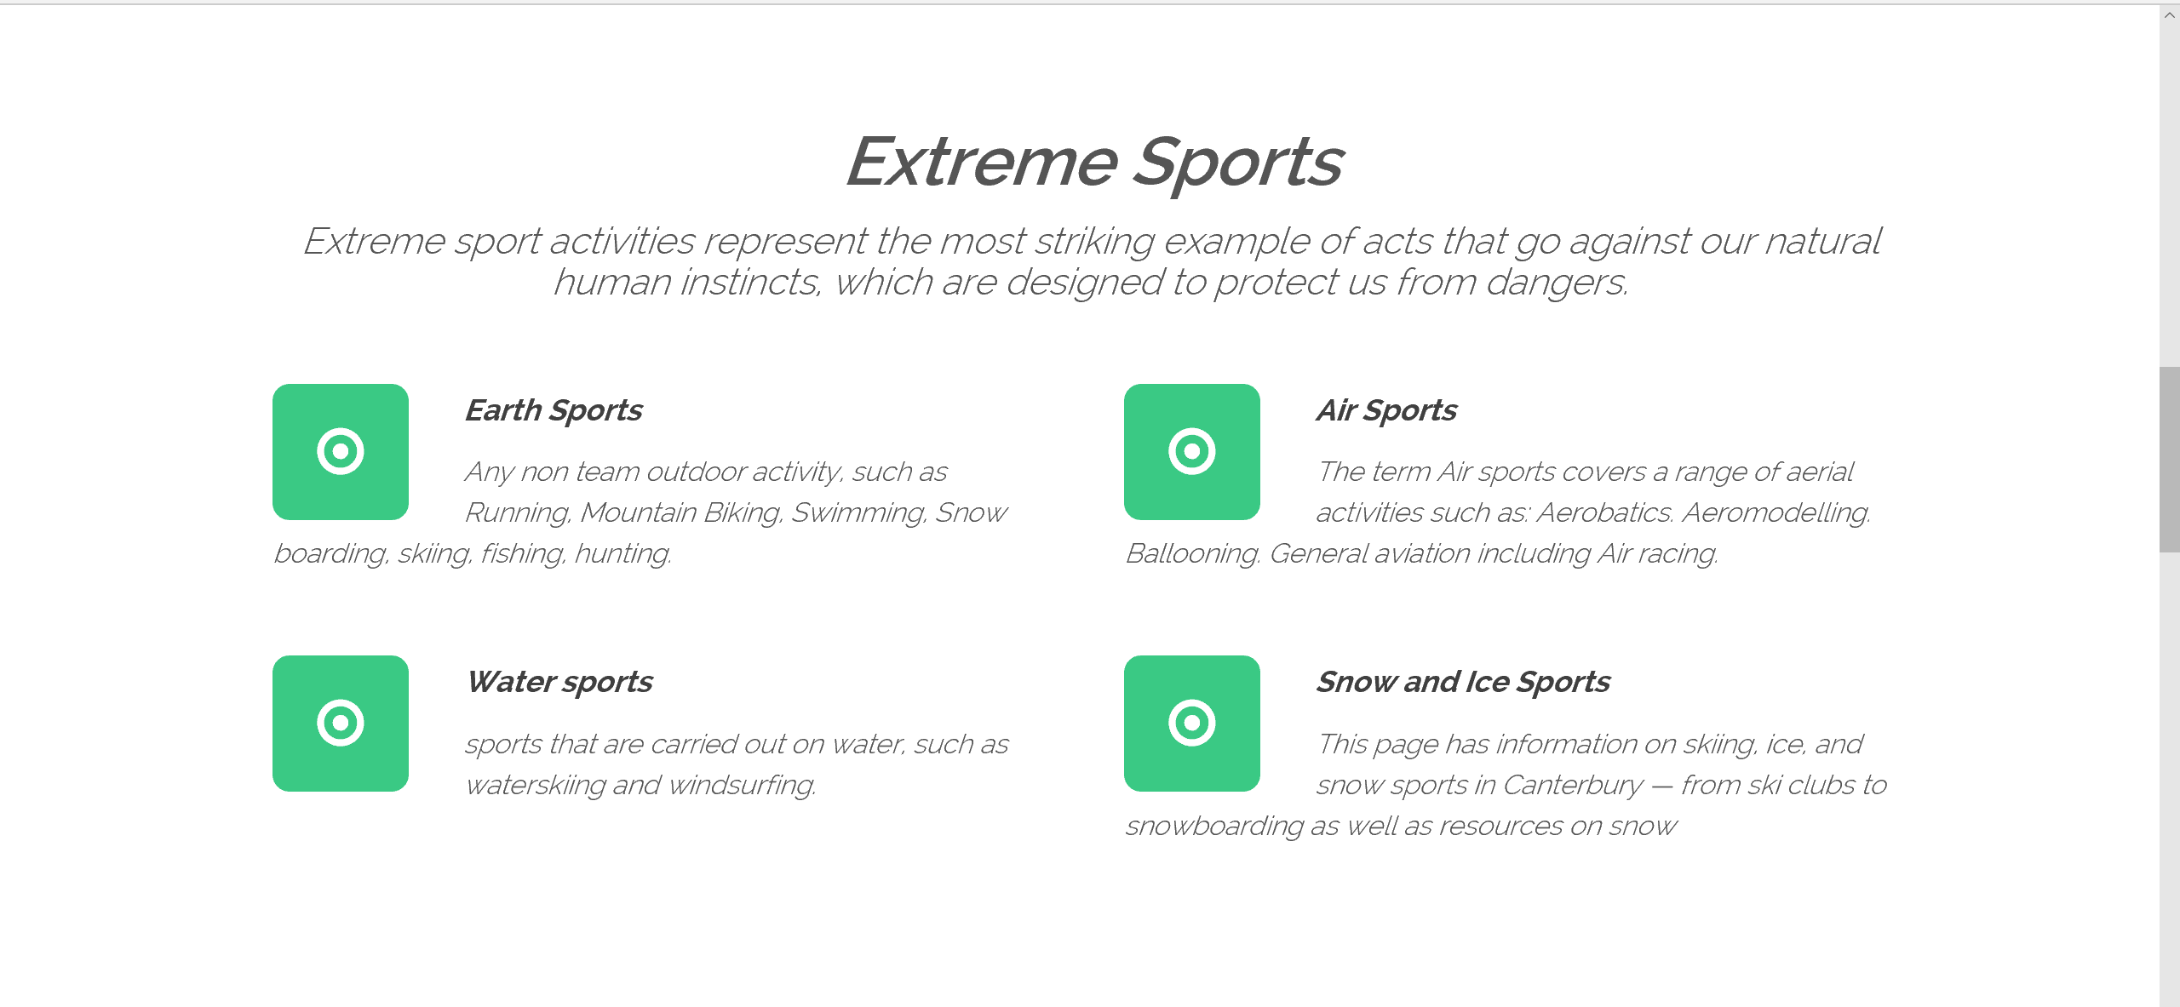

  - Earth Sports

Motocross was first evolved in the U.K. from motorcycle trials competitions, such as the Auto-Cycle Club's first quarterly trial in 1909 and the Scottish Six Days Trial that began in 1912. When delicate balancing and strict scoring of trials were dispensed with in favour of a race to be the fastest rider to the finish, it was called scrambles, said to have originated in the phrase, "a rare old scramble" describing one such early race. Originally known as scrambles racing in the United Kingdom, as the sport grew in popularity, the competitions became known internationally as motocross racing, by combining the French word for motorcycle, motocyclette, or moto for short, into a portmanteau with "cross country".

The first known scramble race took place at Camberley, Surrey in 1924. During the 1930s, the sport grew in popularity, especially in Britain where teams from the Birmingham Small Arms Company (BSA), Norton, Matchless, Rudge, and AJS competed in the events. Off-road bikes from that era differed little from those used on the street. The intense competition over rugged terrain led to technical improvements in motorcycles. Rigid frames gave way to suspensions by the early 1930s, and swinging fork rear suspension appeared by the early 1950s, several years before it was incorporated on the majority of production street bikes. The period after World War II was dominated by BSA which had become the largest motorcycle company in the world. BSA riders dominated international competitions throughout the 1940s.

In 1952, the FIM, motorcycling's international governing body, created an individual European Championship using a 500 cc engine displacement formula.[4] In 1957 it was upgraded it to World Championship status.[4] In 1962, a 250 cc world championship was created.[4] It was in the smaller 250 cc category that companies with two-stroke motorcycles came into their own. Companies such as Husqvarna from Sweden, CZ from the former Czechoslovakia and Greeves from England, became popular due to their lightness and agility.

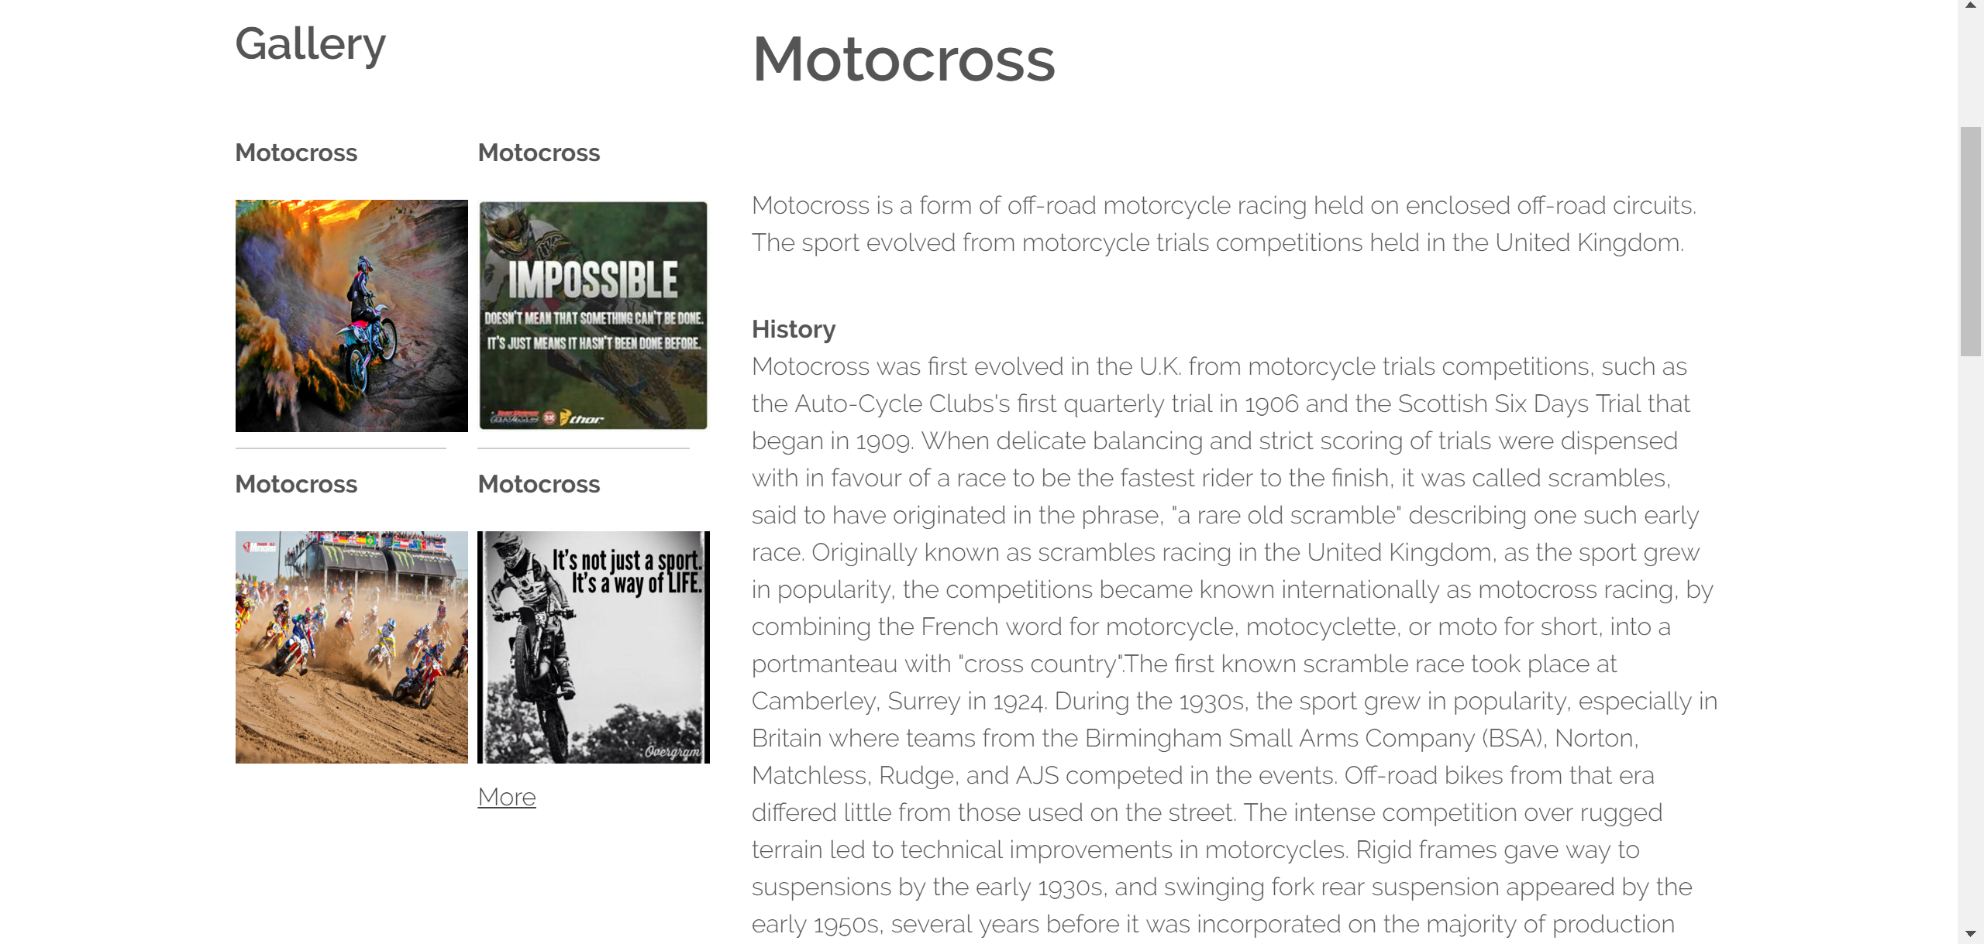

  - Water sports

Water-sport consists of a few categories. Some of these categories are kneeboarding, tubing, slalom skiing and the pencil otherwise known as the "snake”. Water-sport is a lot of fun.

Water sports are a very fun way to get exercise. They are all very diverse from each other and at the same time, similar. Some water sports have just been introduced in the past 100 years while others have been around for centuries. It is the art of self-movement in water by use of hands and feet.Current and tides can make swimming dangerous especially for beginners with little experince.Storks and techniques must be learned by humans. Swimming can also aid in physical therapy and it is general exercise.

Surfing has been a water sport enjoyed by hundred of people around the world.When one goes surfing there are three basic stages that are repeated in a surf session:getting out to the line up,waiting for the rideable wave,and catching a wave and riding it in.Surfing is a exciting and dangerous sport.

Swimming is another very old sport. It as also has been around since before the Greeks. People swim on all of the continents including Antarctica. People swim in Antarctica as part of tournaments to see who can stay in the -1.9 degree Celsius water the longest. There are other tournaments to see who can swim the fastest and do many other things.

In conclusion,these sports have several difrences,so you should try these water sports because you'll have so much fun and keep your shape. Swimming, surfing, boating are fastest increasing water sport in the world.

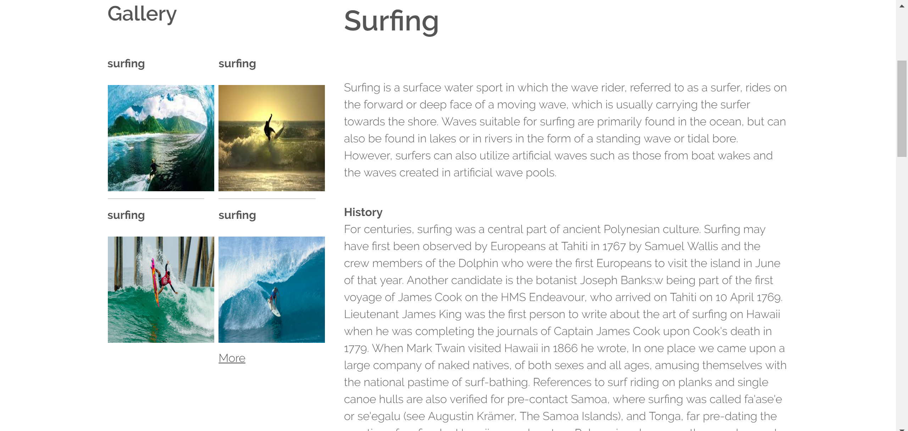

  - Air sports

The term Air sports covers a range of aerial activities such as, Aerobatics, Aero modeling, Ballooning, General aviation including Air racing, Gliding, Hang gliding, Human powered aircraft, Parachuting, Paragliding, Power Kites.

The sports inserted above are governed internationally by Fédération Aéronautique Internationale and at the national level by aero clubs such as the National Aeronautics Association and the Royal Aero Club. The FAI web site contains lists of these national organizations. In some of the categories listed above are lightweight classes which can be alternatively grouped as Ultralight aviation.

Paragliding is the recreational and competitive adventure sport of flying paragliders: lightweight, free-flying, foot-launched glider aircraft with no rigid primary structure.[1] The pilot sits in a harness suspended below a fabric wing comprising a large number of interconnected baffled cells. Wing shape is maintained by the suspension lines, the pressure of air entering vents in the front of the wing, and the aerodynamic forces of the air flowing over the outside.

Despite not using an engine, paragliders flight can last many hours and cover many hundreds of kilometers, though flights of one to two hours and covering some tens of kilometers are more the norm. By skillful exploitation of sources of lift, the pilot may gain height, often climbing to altitudes of a few thousand meters

Paragliding can be of local importance as a commercial activity.[3][4] Paid accompanied tandem flights are available in many mountainous regions, both in the winter and in the summer. In addition, there are many schools offering courses[5] and guides who lead groups of more experienced pilots exploring an area.

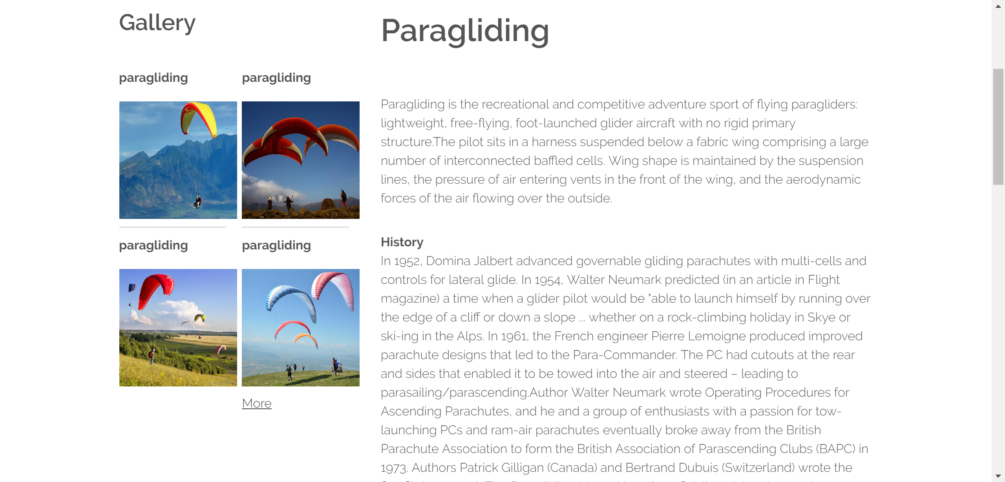

  - Snow and Ice sports

A snow sport is a recreational activity or sport which is played during cold weather months. Most such sports are variations of skiing, ice skating and sledding. Traditionally such sports were only played in cold areas during winter, but artificial snow and artificial ice allow more flexibility. Artificial ice can be used to provide ice rinks for ice skating and hockey in a hot climate.

Common individual sports include cross-country skiing, Alpine skiing, snowboarding, ski jumping, speed skating, figure skating, luge, skeleton, bobsleigh and snowmobiling. Common team sports include ice hockey, curling and bandy. Based on the number of participants, ice hockey is the world's most popular winter sport, followed by bandy.Winter sports often have their own multi-sport tournaments, such as the Winter Olympic Games.

Common individual sports include cross-country skiing, Alpine skiing, snowboarding, ski jumping, speed skating, figure skating, luge, skeleton, bobsleigh and snowmobiling. Common team sports include ice hockey, curling and bandy.

Snow and ice during the wintertime has led to other means of transportation, such as sledges, skis and skates. This also led to different pastimes and sports being developed in the winter season as compared to other times of the year. Naturally, winter sports are more popular in countries with longer winter seasons.

While most winter sports are played outside, ice hockey, speed skating and to some extent bandy have moved indoors starting in the mid-20th century. Indoor ice rinks with artificial ice allow ice skating and hockey to be played in hot climates.

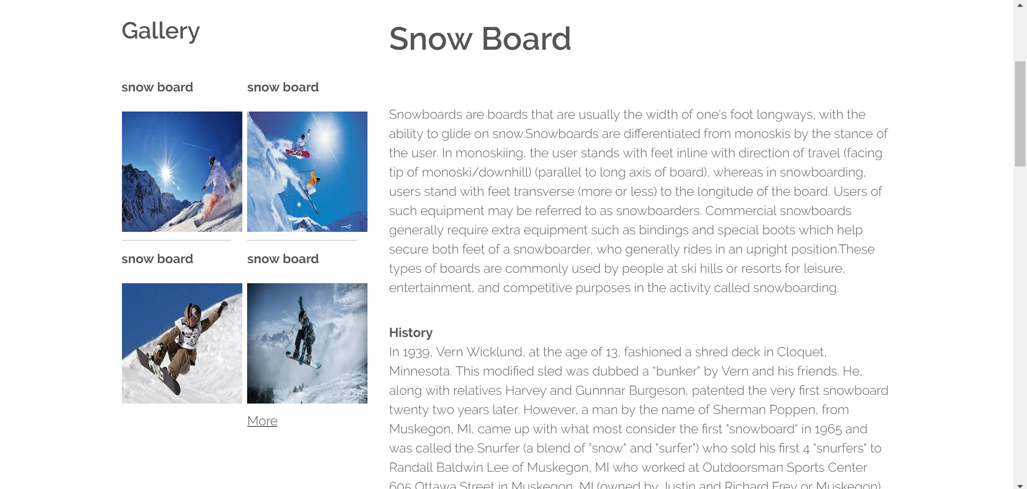

5. CONCLUSION
The purpose of this project is to provide information about extreme sports and some information about the categories. These activities often involve speed, height, a high level of physical exertion, and highly specialized gear. There are however several characteristics common to most extreme sports. Extreme sports tend to be more solitary than traditional sports (rafting and paintballing are notable exceptions, as they are done in teams).
Extreme sports are growing in popularity, especially among young people. New types of extreme activities continue to be developed. Some argue that the popularity is due to marketing trends. They state that marketing strategies give some extreme sports a dangerous image, even though they do not involve high risks of danger.
Regardless, these sports are gaining a large audience and growing in popularity and participation. Magazines, websites, equipment and gear for extreme sports continue to abound.
As people, young and old, continue to develop these activities, more will understand what extreme sports are. While the trend continues, you can expect to see a greater variety of sports available, each one more unique than the last.

REFERENCES

Web Design -------- www.w3schools.com

Software Engineering --------- s.sudarsan Hensry.f.korth
(A Practitioner’s Approach) 5th edition Roger S,Pressman

HTML complete --------- 2nd EditionBPB Publications

Web Design -------- Ivan Bayross Sharanam Shah
HTML/JavaScript/CSS

